1. **Tidal Wave Simulation with Different Initial Condition for Speed**

Assume that length of wave is $10,$ initial condition for position is $1$, and height of wave is $5$.

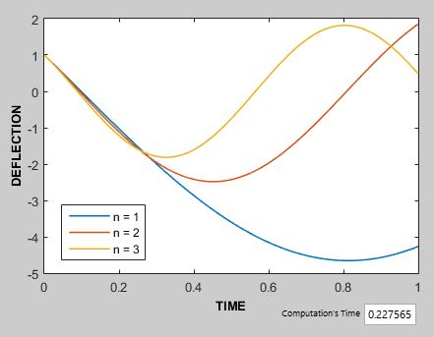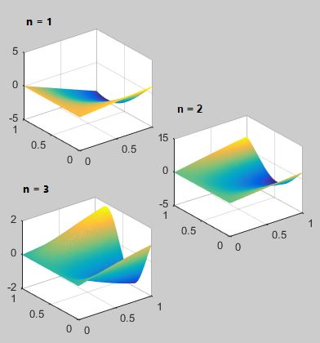

*Figure 8. Tidal Wave Simulation with Initial Condition for Position is $-10$*

*Figure 9. Tidal Wave Simulation with Initial Condition for Position is $0$*

*Figure 10. Tidal Wave Simulation with Initial Condition for Position is $10$*

